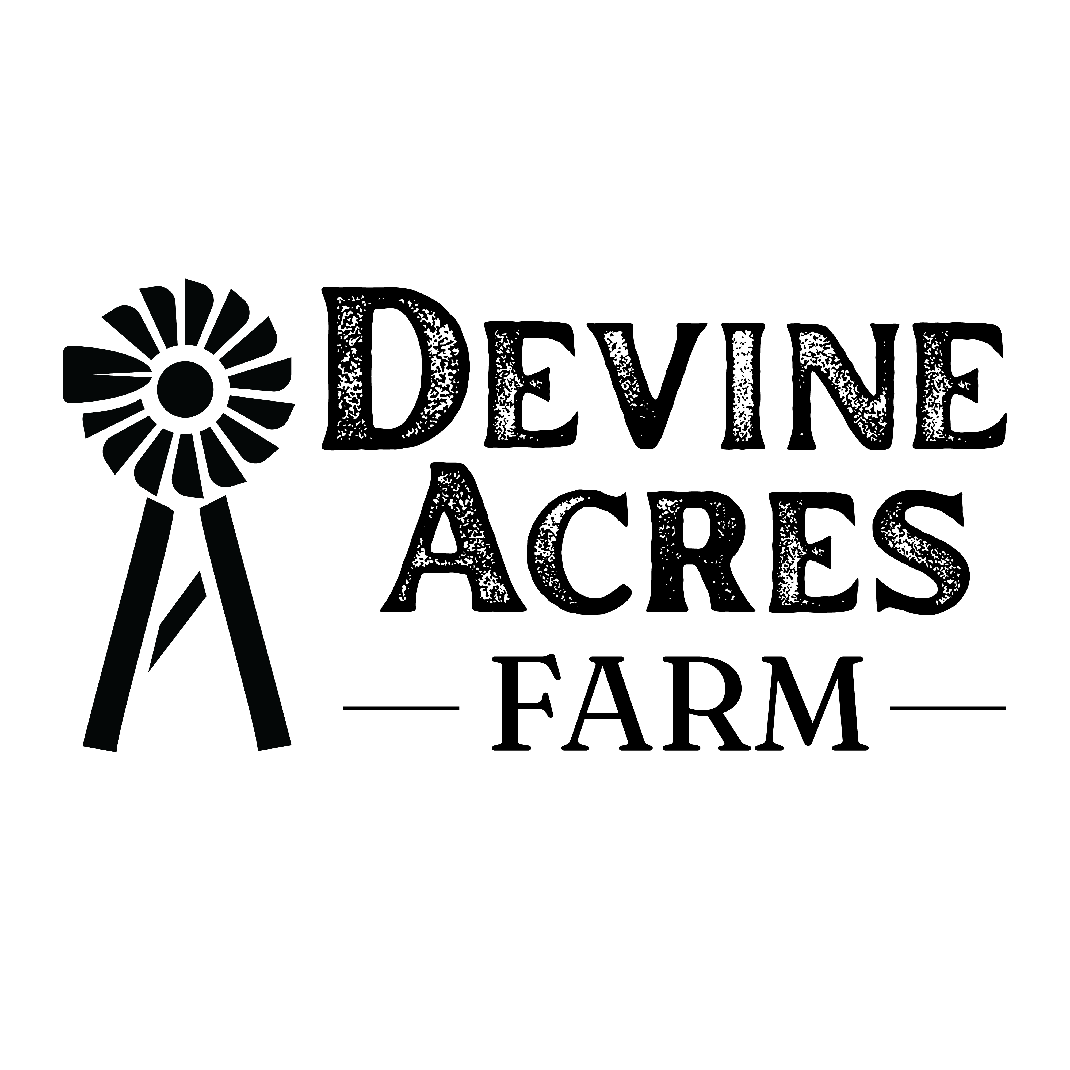
944 FM 2200 W Devine, TX 78016
Dear Parents,

We are excited that your child will be visiting our farm for a field trip! We want to invite you to attend and enjoy a day of fun and learning on the farm! Devine Acres Farm is a 44-acre agri-entertainment Christmas tree farm open to the public for three seasons: fall, Christmas, and spring.

Hours: The field trip will begin between 9:30-10am and end at approximately 1:15pm. The farm closes at 1:30pm.

Admission Fee: Admission is $12 per person for parents and siblings (two and under are free). You will pay admission upon arrival to the farm on the day of the field trip and enter the farm through the back of our gift shop, The Mason Jar Market. We ask that the teachers DO NOT collect parent money in advance, and we DO NOT pre-sale tickets online for weekday field trips. Once your admission is paid you will receive a wrist band and our staff will ask if you want to pre-order for your lunch.

Lunch: You are welcome to bring a lunch or purchase something from our menu. We have 3 options available: ($10 each)
- Pulled pork sandwich & chips
- Chicken salad on a croissant & chips
- Nathan’s all beef hot dog & chips
We ask that you pre- purchase your lunch when you pay your admission to guarantee availability.
Drinks are available for purchase at The Filling Station.

Parking:
Parents will park in one lot; the buses will park in another lot. Please do not go into the parking lot where the buses park as the teachers need to unload, get organized and have the students undivided attention.

Parent Participation:
You are welcome to join your child for every part of the field trip except for the hayride. While students are on the hayride, parents can walk down to our barnyard to meet their child’s class at their next learning station.

Helpful Information: Please make sure that everyone dresses for the weather as all activities are outdoors. Closed toe shoes are recommended.

Forms of Payment: We accept cash, Visa, MasterCard, Discover and American Express.

THERE IS PLENTY OF FOOD, DRINK & SHOPPING!

The Homestead has specialty coffees, fresh baked cookies, roasted nuts, homemade breads and delicious donuts made daily on the farm. You can even take some to go!
Scoops & Grins: we offer hand dipped Blue Bell ice-cream and hand spun shakes!
The Mason Jar is the place to shop for souvenirs, kid toys, books, holiday décor, candles & more!

We look forward to seeing you on the farm!!

