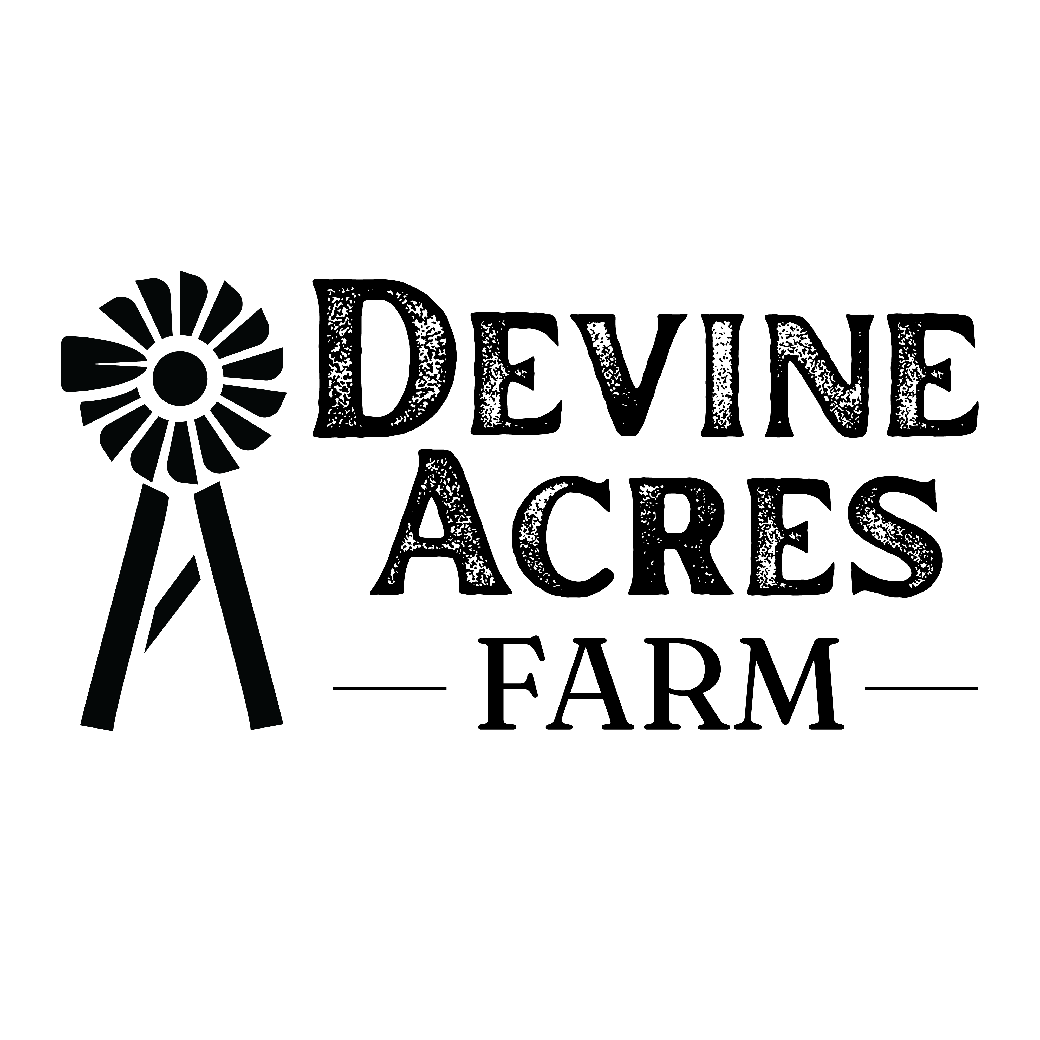

***Important Teacher Information***

*Please share all this information with your team so that you can have the best field trip experience possible*!

**Arrival:** Plan to arrive between 9:15-10am. The field trip will begin once payment is received and students have entered the farm. You will be assigned a guide along with a place to put lunches.

***Parking:*** Parents will park in one lot; the buses will park in another lot. Please advise the bus drivers to look for the lot specified for ‘BUS PARKING’.

**School Field Trip Payment**: Once buses are parked, the teacher in charge of payment will need go to a designated area titled “Teacher Check-In” to pay for the field trip (or present the P.O.), so that remaining teachers and students can enter the farm.

A receipt will be provided. If some students are not able to attend, and the check amount is over, we will reimburse (by check) only if the amount is more than $100. We accept cash, checks, P.O.’s and Visa, Mastercard, Discover, Amex & ACH deposit.

**Teacher Lunches**: Teachers are welcome to bring in lunches or order lunches at the farm (see menu below). The teacher paying for the field trip will need to take orders and collect money in advance for the team so that lunch orders/payments can be taken in conjunction with the school payment. Vouchers for each lunch can be redeemed at our farm kitchen when the students go to lunch.

**Parent Admission:** Parents/family members will pay for their entry and receive a wristband near their designated parking area. Plese DO NOT collect parent money as they are required to pay on their own upon arrival to the farm.

**Trash:** Please make sure that your students pick up all trash throughout the day; especially following lunch! **Please** take the boxes that students lunches came in back to school with you as well any unopened milk containers and/or fruit that the kids did not eat. We appreciate your help with this as we have limited trash reciptiacal space. Don’t forget to grab your ice-chests!

**Facilities**We have clean portable toilets with hand washing facilities available on the farm as well as a handicapped accessible portable facility with a baby changing table.

**Clothing:**Be sure to dress for the farm as well as the weather. Please encourage students to bring jackets if it is cold as all activities are outdoors. Sandals and open toes shoes are discouraged.

**Water**Teachers, be sure to provide your students with drinking water as we do NOT have water fountains on the farm. We do sell bottled Dasani water on site for $3. We do provide igloos with cold water near the lunch area for refills. Cups can be purchases for a minimal cost (10 for $1) to cover our ice/cup expenses. You are welcome to bring your own cups.

**First Aid**:  All activities are outdoors and there are certain risks associated with being outdoors:  bee, wasp, and fire ant stings, hay allergies, etc. We do not administer or distribute any type of medications. The school is responsible for bringing a first aid kit with everything needed for any minor injuries including EpiPen’s, inhalers, Benadryl, etc.

**Cancellation/Re-Schedule**If you need to cancel your field trip, please give us a minimum of 72 hours notice. If you need to re-schedule, please call or email as early as possible as space is limited.

**Late? Lost?** **Worried about the weather?** Please text Debi @ 210-288-6260 ***(PLEASE do not give my personal cell phone out to parents, this is just for the teacher’s use)*** if you are running late, buses are lost, or you have concerns about the weather. Fortunately, our ground is sandy, so rain does not equal mud!

**Parents:**We welcome parents and encourage them to attend the field trip. Please send the letter home for parents (there is an English and Spanish version) so that they are informed about the detour, where to park, times, cost, food options, etc.

**Student Lunches:** Most schools provide lunches for the students; however, we are happy to provide school lunches give a minimum of one week’s notice.

**Lunch Options:**

We have 3 options at a cost of $10 each: *(Drinks are available for purchase at The Filling Station)*

1. Chicken Salad on a croissant with chips.
2. Nathan’s all beef hot dog with chips.
3. Pulled Pork Sandwich with chips.